Trouble adding Burn Queues?

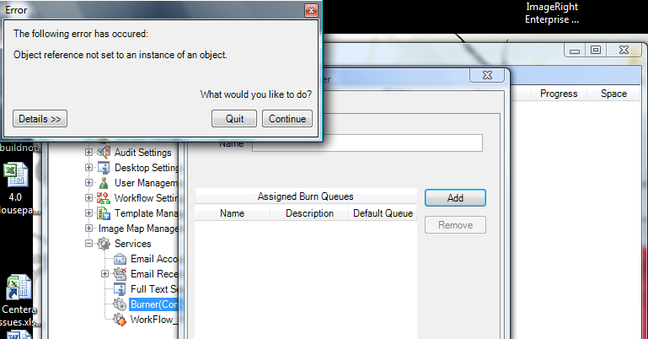

Check the emc config file and change the localhost to the name of the app server

